|  |
| --- |
|  |



**18 January 2013** **The Weekly Bulletin of Rotary Club of Kathmandu Mid-Town** **Bc-18.1/012-13**

**District : 3292 Web: www.rotarymidtown.org.np Club Id : 26776**

**JANUARY IS ROTARY AWARENESS MONTH**

Celebrate Rotary Awareness Month by providing members orientation on [Rotary history](http://www.rotary.org/en/aboutus/history/Pages/ridefault.aspx), programs, or on how to [raise awareness](http://www.rotary.org/en/Members/RunningAClub/InformingTheCommunity/Pages/PromotingRotary.aspx) of the club’s project activities in the community.

Motivate members to share a personal story or experience that they have had because of Rotary. Every Rotarian has a Rotary story that can be educational and inspiring. The beginning of a new year is a good opportunity to renew inspiration for the rest of the Rotary year.

Friday, 11 January:

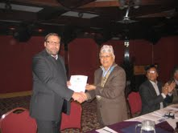

Guest Speaker Ambassador Asko Luukkainen highlighted in brief

various aspects of Finland-Nepal Relations. HE expressed his

pleasure over the existing state of Nepal-Finland ties which as per

the Ambassador remained in an 'excellent state.'

Shedding some light on the Finnish assistance to Nepal, Ambassador

Asko revealed that his country had been extending financial

assistance to Nepal to the tune of 50 million Euros on an annual basis

in the sectors of education, health, energy, small hydro power

projects and environment. 'We have been providing innovative

solutions to Nepal in these sectors,' HE claimed. The Ambassador

frankly admitted that Nepal was selected as Finland’s long-term

partner in development simply because Nepal was the poorest of all among the Asian nations.

In the picture, President Devendra handing over letter of appreciation to Guest Speaker Ambassador Asko.

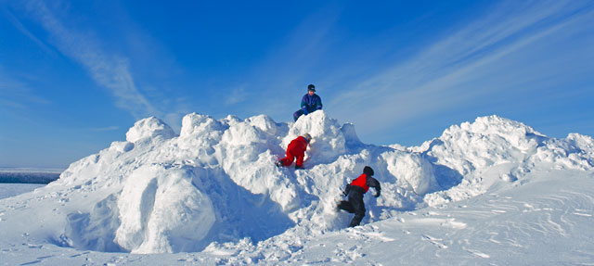

*Winter in Finland. Looks very nice, isn't it ?*

# Weekly Meetings and Programs :

|  |  |  |
| --- | --- | --- |
| Date | Program/Speaker | Program/Topics of Presentation |
| 18 Jan 2013 | Prachanda M Shrestha | Tourism in Nepal |
| 25 Jan 2013 | ?? |  |

Friday, 11 January *Cont'd*

PHF Pin and Certificate

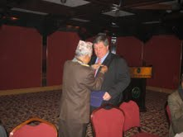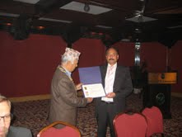

*President Devendra providing PHF pin to Rtn Bodde and certificate to Rtn Paras*.

Friday, 18 January:

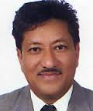

Rtn Prachanda M Shrestha, a name well known in the Tourism *Industry* (?) in Nepal, is

going to talk on Tourism in Nepal. He was Director General in the Department of

Tourism, HMG and Joint Secretary in Department of Industries before he resigned from

the government service to join in a very challenging job as the CEO of Nepal Tourism

Board. He completed his tenure in NTB last year. He has significant contributions

in Nepal's tourism sector in policy level and also in Nepal's joining World Trade

Organization. Do not miss to hear from the horse's mouth.

**From the Club Secretary's Desk:**

Dear Fellow Members:

Your Board in its last Meeting on 9th January 2013 has approved the Membership of Dr. Deepak Bajracharya as proposed by PP Pratap.

Following due process, and as advised by the Board, I am forwarding the CV of the proposed new Member for your reference and endorsement of the Board's decision. As you are aware, if no valid (validity or otherwise to be determined by the Board) objections are raised in writing addressed to me as the representative of your Board within the next 7 days, i.e. by ***9.30 AM*** on ***Monday,*** ***21st January, 2013,*** the new membership of Dr. Deepak Bajracharya will be deemed to be accepted.

Just as a matter of e-mail courtesy and discipline, please do not email me your approvals - a 'no response' to this email will be construed as an approval !

Buddha Laishram, Club Secretary

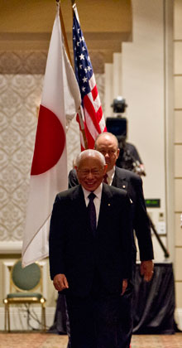

… wear your Rotary pin. It makes you think more before you speak and before you act. It

makes you remember, all the time, that you are a Rotarian – and that as Rotarians, we are

here to help.

**RI President Sakuji Tanaka**

**Committee Chairpersons' Column:**

**Exploring Grants from the Rotary Foundation:**

The Rotary Foundation offers multiple types of grants to serve the wide variety of projects that Rotarians are doing around the world. Explore the different grant types to find which one is right for your activity.

**District grants**: District grants fund smaller, short-term activities that address needs in both your local community and communities worldwide. Each district gets to choose which projects it will fund with these grants.

**Global grants:** Global grants support large international activities with sustainable, measurable outcomes in one or more of the six areas of focus. The Rotary Foundation accepts global grant applications on a rolling basis throughout the year.

**Packaged grants:** Packaged grants have been predesigned by Rotary and our strategic partners. The activities they fund are similar to those funded by global grants, but the work of designing the activity’s general framework has already been done.

How do these grant types compare?

While all Rotary Foundation grants support meaningful activities around the world, they do differ in a number of ways.

**District grants Global grants Packaged grants**

***What they support*** Mission of TRF Six areas of focus Six areas of focus

***Impact length***  Short-term Long-term Long-term

***Minimum budget*** None US$30,000 US$20,000

***Scholarship types available*** All levels of study, Graduate-level, Varies by opportunity

both local and international

international

***Who administers them*** District TRF TRF

***Where funding comes from*** District Designated Annual Fund, donations World Fund and

Fund to specific grants, strategic partners

endowment earnings,

, term gifts

Looking for other Rotary funding?

**District Simplified Grants:** District Simplified Grants help Rotary districts support short-term humanitarian projects that benefit the community. These grants are being phased out, but we will accept applications for them until 31 March 2013.

**Rotary Peace Fellowships:** Rotary Peace Fellows are chosen from countries and cultures around the globe based on their ability to have a significant, positive impact on world peace and conflict resolution during their careers.

**Matching Grants:** Matching Grants match contributions for international service projects by Rotary clubs and districts. Grant awards range from US$5,000 to $200,000. These grants are being phased out, but we will accept applications for them until 31 March 2013.

**Future Vision pilot:** The 100 pilot districts may continue to apply for global grants in the Member Access system until 31 March 2013. District grant applications are also available to pilot districts until 15 May 2013.

**Public Image grants:** Public Image grants help districts promote the positive impact of Rotary. Districts may apply for a grant of up to US$15,000.

*courtesy:* *Rtn Rabi Karmacharya, Chairperson, TRF Committee*

**Past Presidents' Column:**

**?????**

On lighter side :

Click here ⇩



A thought for the day:

**In our world of big names, curiously, our true heroes tend to be anonymous.**

**In this life of illusion and quasi-illusion, the person of solid virtues**

**who can be admired for something more substantial than his well-knownness**

**often proves to be the unsung hero:**

**the teacher, the nurse, the mother, the honest cop, the hard worker**

**at lonely, underpaid, unglamorous, unpublicized jobs.**

- Daniel J Boorstin

*courtesy:* Rtn Dr Isabella C Bassingana Khadka

Great quotes:

***It’s not important to hold all the good cards in life.***

***But it’s important how well you play with the cards which you hold !***

Puzzle:

**This week's puzzle: If 00 = 8, 01 = 9, 11 = 7, 111 = ?**

Last week puzzle solution: If 1 = 5, then 5 = 1; That's it !

NB: Send any informations/photos that may be of interest to the Club or Rotarians in general to

BC Editor: RR Shrestha email: rryesrr@gmail.com

## 18 Jan 2013 The Weekly Bulletin of Rotary Club of Kathmandu Mid-Town bc-18.1/012-13